**Introduction to Programming EE2310 Homework 5**

**103061142 楊淳佑**

**Problem**

To create a menu of a customer service center.

**My Solution**

Using several functions and call each other to make the menu.

**Additional Features**

* In the Product Repairing part, the program will detect the date today and the day user bought the product. The warranty period of every product is 1 year. If the warranty has expired, the bill will be generated automatically. The fee of repairing will be $100 every year.
* Users doesn’t need to close the program to log out. Since the repair/return number will be in the form of serial numbers, the repair/return number will be automatically generated one by one.
* When users need to enter the product model and don’t know what to key in, users can enter “help” to check the product list.
* There is a breadcrumb on the top of every page so that users can know where they are clearly.

**Program Flow & Structure**

* int Login(): To get the user’s name and ID, and save into file.
* int main(): The first level menu. Also will check the login status. If the user is not logged in (id==0), it will call Login().
* int inq(): The second level menu.
* int productModel(): To let the user input the product model and check if the input is correct.
* int productNumber(): To let the user input the product number and check if the number is valid (the range varies by different model).
* int Repair: Call productModel() and productNumber() first, then let the user input date and address. Then generate the repair number and the bill if needed.
* int Return: Call productModel() and productNumber(), then generate the return number.
* int endMenu: To let users choose if they want to logout or go back to the main menu when they are finished with report or action.

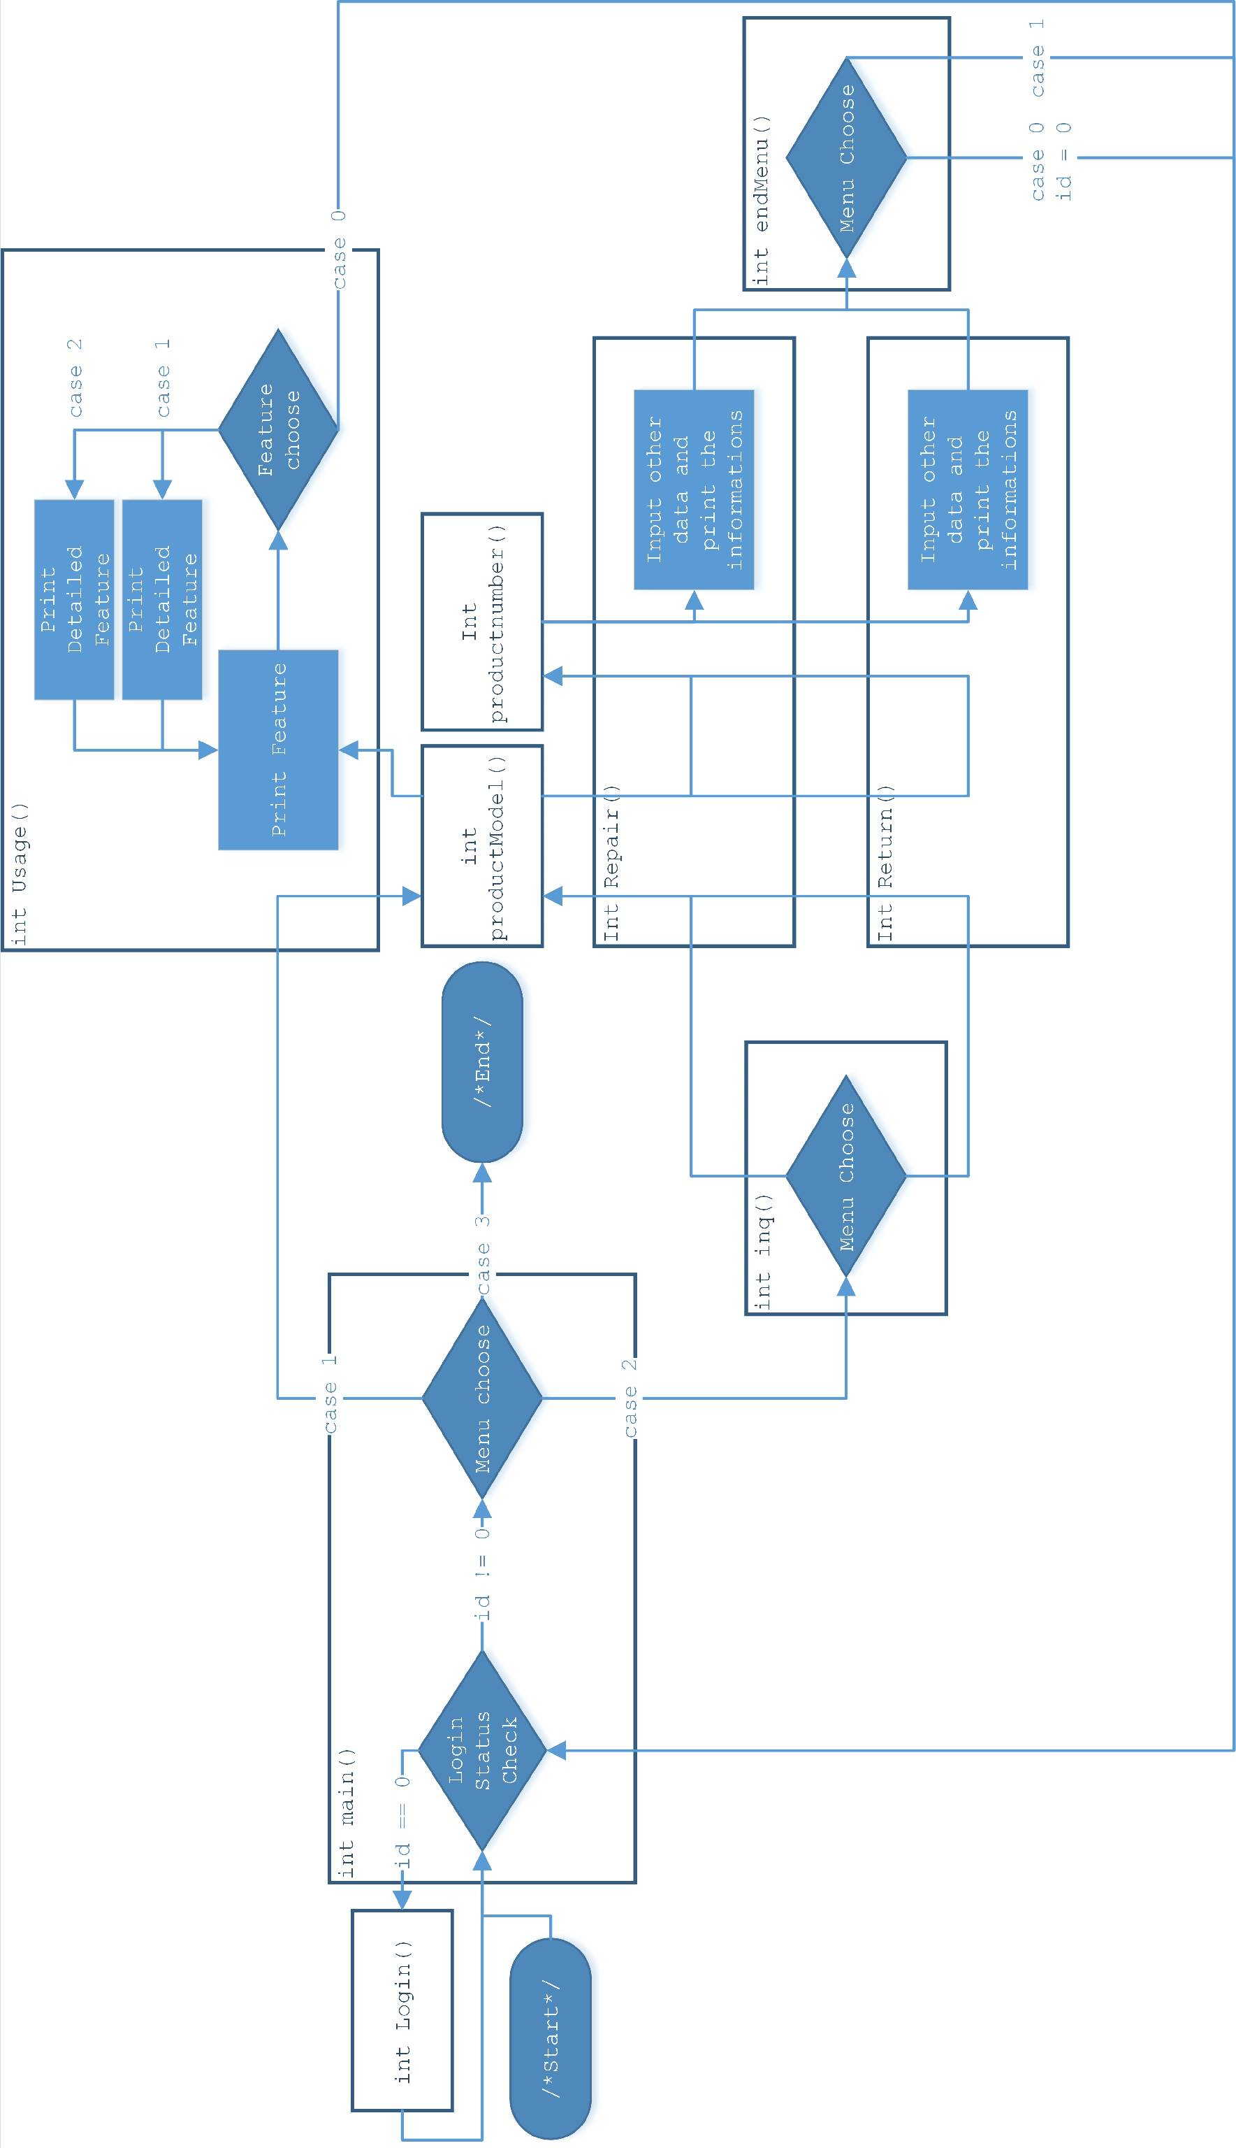

**Output Result**

